Rabea Ahmed

1711894042

Week 2 - Paper Review

CSE499B

# An Intelligent System for Conversion of Bangla Sign Language into Speech

October 2018

**Abstract**

Bangla sign language conversion into speech is a key to help vocally impaired people to express their feelings easily. In this project, a pair of smart gloves with sensors and microcontroller is developed which can convert Bangla sign language into Bangla speech. Flex sensors are used to measure the bending of fingers, accelerometer and gyroscope sensor are used to measure hand position and movements. The proposed system is evaluated with 8 people with 248 samples of 72 words. Experimental results show that the system is functioning well and can detect the sign language with 99.5% accuracy. The user can change the pronunciation of words with the variations of tense and pronoun in Bangla sentences.

**Introduction**

Sign language is a protocol of communication using visual gestures and signs. It is varying with different geographical regions and languages. Bangladesh also has her own sign language which known as Bangla sign language (BSL). Vocally impaired cannot express their feelings as normal people does due to their vocal impairments. Instead of vocal speech they are used sign language for any expression. The number of vocally impaired or speech impaired in the world are roughly calculated to be from 70 to 90 million. In Bangladesh the number of people who is sign language is 2.4 million and this number is increasing day by day. Because vocally impaired people in Bangladesh teats less important than other country. In this work, a system is developed that can convert the Bangla sign language into speech which may be useful for establishing better communication with other people.

**Literature Review**

The researchers emphasized on quantitative evaluation for this project. They worked with 8 people, 6 are males and 2 females, in the real environment to run this experiment. The average ages of participants are 24 years. Their average height was 155 cm. Most of them knew Bangla Sign Language. The participants were requested to wear the hand gloves which was connected to the computer to start the application. Then the participants had to show some sign language.

**Methods**

Step 1: Wear the hand gloves on both hands. Then turn on the hand gloves by using switch. Both the gloves were connected with wire.

Step 2: Select the tense from tense circuit board on left hand and select the pronoun from pronoun selection board on right hand.

Step 3: Then in computer we open signLanguageDetection.py file of this work. It will open in python development tool PyCharm.

Step 4: Its important to start mysql server by openning xampp application, then simply click start button of mysql.

Step 5: Run the signLanguageDetection.py file by clicking the run icon on the top right corner. It took some time to connect with the hand gloves via Bluetooth. It was made sure that the connection was successful by checking the blinking rate of Bluetooth module. When it is successfully connected it will blink in every two second otherwise it will blink very rapidly.

After all those set up, the experiment could start. When a sign starts to act then we have to press a button on with our left thumb. Then after finish a sign we should release the button. With that the hand gadget set sends value string to computer using Bluetooth. Then computer process the value. And give output as a sound track of corresponding sign and play it on speakers. This process should flow every time if we disconnect the device. And need to convert sign language again

**Results**

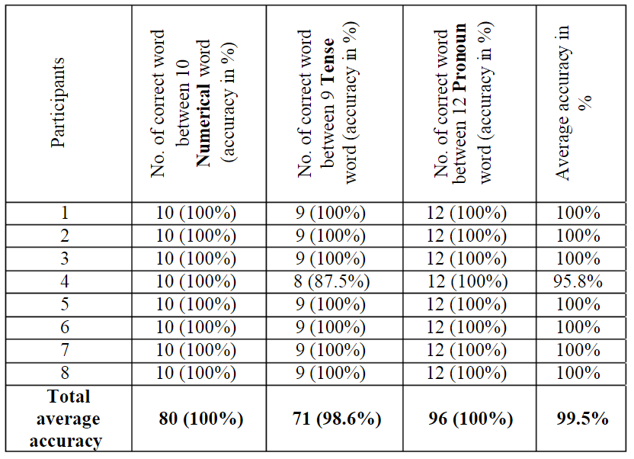

**Conclusion**

The main purpose of this project was to design an intelligent system than can convert Bangla sign language into Bengali speech. A frame was built which could detect the Bangla sign language and convert into speech. A pair of smart gloves was designed with sensors. Microcontroller was programmed to measure the level of bending of fingers, hand position and movements. This design may be used for vocally challenged people. With this pair of gloves, they would be able to share their feelings to normal people, who don’t need to learn Sign language to understand what vocally challenged people wants to say. The current implementation has some limitations such as its need to record every sound for every sign. Conversion of neural language and detection sign langue in android devices may increase the robustness and flexibility of the current system. These issues are left for future improvements.

**Reference**

[(PDF) An Intelligent System for Conversion of Bangla Sign Language into Speech (researchgate.net)](https://www.researchgate.net/publication/334078163_An_Intelligent_System_for_Conversion_of_Bangla_Sign_Language_into_Speech)